Statement of the Hasan Ferit Gedik Center for Struggle and Liberation from Drugs, after its center was pulled down last night by the police and patients were arrested.
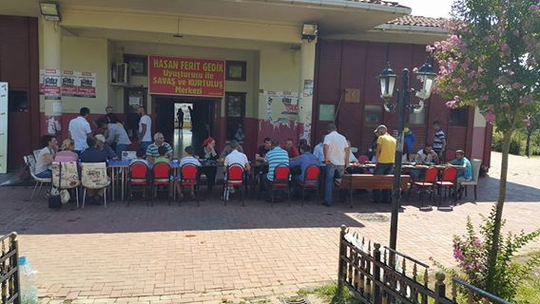
​Picture: short time ago breakfast in front of the center with patients and families

The murderous police of the AKP pulls down the HFG Center for
Struggle and Liberation from Drugs!!

On Wednesday, 31st August 2016, around 3.00 am in the morning, the murderous police of the imperialist servant AKP totally surrounded thet neighborhood Gazi, attack several institutions and workplaces, demolished them with bulldozers.

It has also attacked the HFG center for Struggle and Liberation from drugs and arrested all patients inside. The center was surrounded with barriers and they completely prevented anyone from entering the building.

Only a few days ago, the murderous police rescued drug dealers from the hands of the people with a armoured vehicle. Now it attacked the HFG Center for Struggle and Liberation from Drugs, arrested its patients, who receive treatment there. By razing the treatment center to the ground, it showed again that it is the protector of the drug dealers.
THE STATE IS BEHIND THE DRUGS, WE ARE AGAINST THEM!

Therefore they frequently attack our institution. But, whatever they might do, they won't be able to prevent us from drying this swamp.
Whenever they attack and destroy, we will create a bigger, nicer and better one.

The Istanbul police will be responsible for everything that might happen to our patients. Our arrested patients have to be released immediately!

WE CALL UPON ALL OUR FRIENDS AND PEOPLE TO SUPPORT OUR INSTITUTION!"

